NON-RT-RIC
The non-RT RIC is a type of controller. It helps control and improve RAN elements and resources. It includes an AI/ML workflow for model training and updates. It also provides policy-based guidance for applications and features in near-RT RIC.
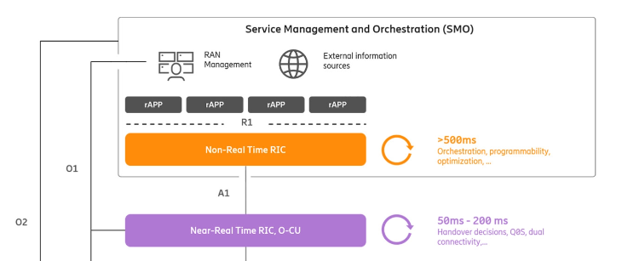

Fig: NON-RT RIC functionalities

The Non-RT RIC is a component of the Service Management and Orchestration (SMO) system, which is defined by the O-RAN Alliance. It comprises a platform and a group of microservices called rAPPs that embody the intelligence. The system's design is rooted in the following principles:
- Access to information: The RAN does not have the information needed to manage radio resources and improve its performance. This information includes application-level data, cross-domain information, UE positions, mobility trajectories, and external information.
- Real-time optimization: In the past, management and orchestration of the RAN used to take hours. But with better interfaces and automation, the Non-RT RIC can optimize the RAN within as little as half a second.
- End-to-end service assurance : The Non-RT RIC can address a broader range of use-cases that were previously not feasible by optimizing the RAN on a user level as well as per-node level.
- AI/ML programs: The Non-RT RIC was designed for AI/ML from the beginning, and it is being used to incorporate AI/ML-based software to control the RAN.
- Innovative collaboration : We can create a system where intelligent controller software applications (rAPPs) share data and insights with each other in an open ecosystem.
The Non-RT RIC is placed in the Service Management and Orchestration (SMO) to get more information that can help improve the RAN. The RAN nodes like CU, DU, and Near RT-RIC cannot get this information. With the Non-RT RIC, it is possible to coordinate the optimization of radio and transport to adjust user-level throughput based on application performance and contextual prioritization, which is not possible in existing networks.

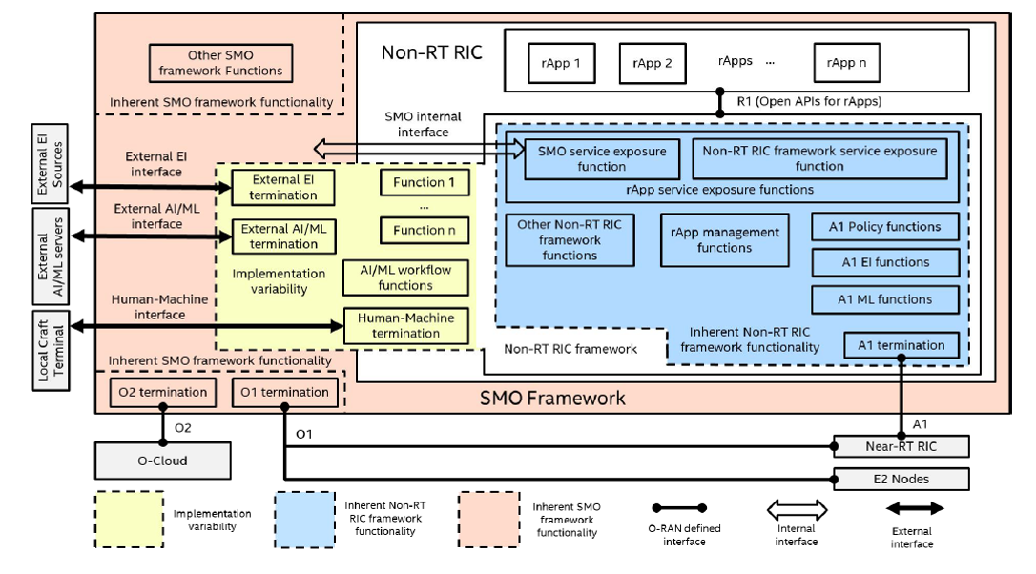

Fig: Non-RT RIC architecture functional view diagram
The diagram in the figure shows the Non-RT RIC architecture functional view. The Non-RT RIC is part of the SMO framework and has three categories of components: rApps, Non-RT RIC framework, and Open APIs for rApps.
- An rApp is an application that works with the Non-RT RIC.
- The Non-RT RIC framework is a group of functions for the Non-RT RIC.
- The R1 interface (Open APIs for rApps) is a way for rApps to communicate with the Non-RT RIC framework. It includes services like registration, discovery, AI/ML workflow, and A1 services. It doesn't matter if the services are part of the Non-RT RIC or SMO framework, as the open APIs work with both.
The Non-RT RIC has functions that are essential and important for supporting the A1 interface and rApps. These functions are called inherent Non-RT RIC framework functionality, and they are shown as the blue area in the diagram. The A1 functions, which are the termination point of the A1 interface, are also part of the inherent Non-RT RIC functions. The A1 functions include the A1 logical termination and functions that support A1 services such as A1 Policy functions, A1 EI functions, and A1 ML functions.

The Non-RT RIC needs some functions to manage and expose rApps. One of them is the "rApp management functions," which includes conflict resolution between different rApps. These functions are inherent to the Non-RT RIC framework.
Another function needed is the "R1 service exposure functions," which includes service registration, discovery, and authentication/authorization. Non-RT RIC and SMO frameworks provide services that rApps can access through the registration and discovery function. However, rApps need to be authenticated and authorized by the authentication function to access these services.
The diagram shows a placeholder called "other Non-RT RIC framework functions" that might be identified later. These functions will also be part of the Non-RT RIC framework.
In the diagram, there is a yellow area called "implementation variability." This area includes functions whose deployment depends on the specific implementation. If an implementation variable function is deployed in the Non-RT RIC, it is considered a part of the Non-RT RIC framework, and rApps can discover its service through the service registration and discovery function. But if it is deployed in the SMO framework, it is not a part of the Non-RT RIC framework, and rApps can still discover its service through the same function. It is up to the implementation to decide where to deploy these functions.
The diagram in Figure three shows examples of "implementation variable" functions, such as external EI termination, external AI/ML termination, and human-machine termination. External EI termination imports enrichment information from external sources, external AI/ML termination connects to an external AI/ML server to import ML models, and human-machine termination allows manual injection of RAN intent. These terminations can be inside or outside of Non-RT RIC, depending on the implementation. There are many more "implementation variable" functions, such as AI/ML model training, data analytics, and data sharing. Placeholders like "Function 1" to "Function n" are used in the diagram for more implementation variable functions. However, the specification of these external interfaces is still up for discussion.
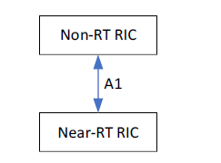

Fig: A1 interface between two RIC.

The Non-RT RIC function is located in the SMO layer, which also handles deployment, configuration, and data collection from RAN nodes. The SMO layer includes functions for AI/ML workflow, such as training and updating ML models, and deploying other applications. Enrichment information from sources outside of the RAN network can also be used to enhance RAN guidance and optimization functions. The SMO layer's main purpose is to optimize RAN performance to meet SLAs specified in RAN intent. The A1 interface enables the Non-RT RIC function to provide policy-based guidance, ML model management, and enrichment information to the Near-RT RIC function to optimize RRM under certain conditions.

The Non-Real-Time RIC (Non-RT RIC) can develop policies for the Near-Real-Time RIC (Near-RT RIC) to guide the RAN performance towards the overall goal expressed in RAN intent. These policies are created based on high-level goals for the system expressed in RAN intent and on observables provided over O1 (events and counters). The policies are declarative and contain statements on policy objectives and resources applicable to UEs and cells.

The Non-RT RIC can manage the policies provided over the A1 interface by using A1 policy feedback and network status information provided over O1. By continuously evaluating the impact of the A1 policies using O1 observables, the Non-RT RIC can update the goals expressed in the policies based on internal conditions.
The Near-RT RIC operates based on its internal functions or applications, the configuration received over O1, and the temporary policies received over A1. However, it should be noted that the A1 policies may not survive a restart of the Near-RT RIC.
To support policy enforcement in the Near-RT RIC, the Non-RT RIC can provide enrichment information over the A1 interface.

A1 interface general principles:
The A1 interface is a key component of the O-RAN architecture that allows the Non-Real-Time RIC (Non-RT RIC) and Near-Real-Time RIC (Near-RT RIC) to communicate and work together efficiently. The general principles for this interface are as follows:
• The A1 interface is an open logical interface between the Non-RT RIC functionality in the SMO and the Near-RT RIC functionality in the RAN, which enables a multi-vendor environment and is independent of specific implementations of the Non-RT RIC and Near-RT RIC.
• The A1 interface is designed to be extensible, meaning that new services and data types can be added without needing to change the protocol stack or the procedures.
• The A1 interface enables policy-based guidance of radio resource management internal functions or applications that are part of the Near-RT RIC, allowing for efficient resource management.
• The A1 interface provides a basic feedback mechanism from the Near-RT RIC that enables the Non-RT RIC to monitor the status of policies.
• The policies transferred over the A1 interface must be expressed using a standardized mechanism, such as a common language and syntax, to ensure consistent interpretation.
• The A1 interface also enables transmission of A1 enrichment information from the Non-RT RIC to the Near-RT RIC as needed, and the Near-RT RIC can discover available enrichment information for which secure delivery can be provided.
• A1 policies are created, modified, and deleted by the Non-RT RIC based on context information, such as observability from the RAN indicating RAN intent fulfillment received over O1. The policies are enforced until deleted, and the A1 interface allows the Near-RT RIC to provide feedback to the Non-RT RIC regarding the enforcement status of these policies.
• EI (enrichment information) jobs are created, modified, and deleted by the Near-RT RIC based on the needs of its internal functions.
• The Non-RT RIC delivers A1 enrichment information to the Near-RT RIC according to an EI job as long as the job is enabled and until it is deleted.

The Non-RT RIC utilizes the policy management function to handle the provisioning and administration of A1 policies in the Near-RT RIC. The function enables the creation, modification, and deletion of A1 policies in the Near-RT RIC. Additionally, it allows for the retrieval of information on the existence, content, and real-time status of A1 policies in the Near-RT RIC. A1 policy feedback is also supported, enabling the Near-RT RIC to provide information on changes in enforcement status to the Non-RT RIC.
It is important to note that the Near-RT RIC can only notify the Non-RT RIC of changes in enforcement status and not change the content of a policy. If a change in context results in a change in enforcement status, the Non-RT RIC is informed and may decide to delete the policy. Fulfilment feedback of A1 policies in the Near-RT RIC is not transferred via the A1 interface, but the Non-RT RIC can use O1 observables to estimate it.
The Non-RT RIC may also monitor the network before and after the creation of an A1 policy to assess its impact on performance. However, performance monitoring or tracing is not supported over the A1 interface.

Aspects of R1 Interface:

Fig: R1 interface as a collection of services between the Non-RT RIC Framework and rApps

The R1 interface in O-RAN has some important principles to keep in mind:

It's a logical interface between rApps and Non-RT RIC framework.
It's used for exchanging control signaling information and collecting/delivering data.
It allows multiple vendors to use R1 services and is not tied to specific SMO or Non-RT RIC framework implementations.
It can be extended to add new services and data types without changing protocols or procedures.

rApp:
Applications using the Non-RT RIC Framework and SMO Framework offer RAN-related value-added services. These services cover radio resource management, data analytics, and information enrichment. The rApp can perform the following tasks:
- Query supported A1 policy types.
- Subscribe/unsubscribe to notifications for changes in supported A1 policy types. SMO/Non-RT RIC framework informs subscribed events (e.g., adding new policy types, removing existing policy types).
- Create A1 policies in the SMO/Non-RT RIC framework. The framework assigns unique policy identifiers to created A1 policies.
- Update A1 policies created by the rApp using assigned policy identifiers.
- Query A1 policies applied to a given scope (e.g., UE, group of UEs, slice, QoS flow, cell, Near-RT RIC, policy type, etc.). The SMO/Non-RT RIC framework returns queried A1 policies with assigned policy identifiers.
- Query A1 policies using policy identifiers if known to the rApp.
- Query A1 policies created by the rApp itself.
- Query A1 policies created by other rApps with authorization from the SMO/Non-RT RIC framework.
- Subscribe/unsubscribe to notifications for the creation, modification, and deletion of A1 policies created by other rApps. The SMO/Non-RT RIC framework notifies subscribed events (e.g., creating a new A1 policy, updating or removing an A1 policy).
- Subscription request can be based on a given scope to which A1 policies are applied (e.g., UE, group of UEs, slice, QoS flow, cell, Near-RT RIC, policy type, etc.).
- Subscription request for A1 policy modification and deletion can be based on policy identifiers if known to the rApp.
- Subscribe/unsubscribe to notifications for changes in enforcement status of A1 policies. The SMO/Non-RT RIC framework notifies subscribed events. The rApp needs authorization from the framework to receive notifications related to enforcement status changes of A1 policies created by other rApps.

Non-RT RIC Inherent Functions: This actor is used when the function is part of Non-RT RIC Framework.
SMO Inherent Functions: This actor is used when the function is not part of Non-RT RIC or rApp.
Implementation Variable Functions: This actor is used when the function can be part of Non-RT RIC or not in a particular implementation.

